**INSIGHT STREAM (News Reading App)**

**Naan Mudhalvan Project**

Submitted in partial fulfillment of the requirement for the award of

**BACHELOR OF COMPUTER SCIENCE**

Submitted By

**A.BHARATH-asunm110222201144**

**M.BHUVANESHWARAN- asunm110222201146**

**C.MOHAN DASS- asunm110222201161**

**H.SAI ROHITH- asunm110222201169**

**S.SHYAM KUMAR- asunm110222201172**



**UG DEPARTMENT OF COMPUTER SCIENCE**

**DHARMAMURTHI RAO BAHADUR CALAVALA CUNNAN CHETTY’S**

**HINDU COLLEGE [SHIFT-II]**

**“LINGUISTIC (TELUGU) MINORITY STATUS**

**CONFERRED BY THE GOVT.OF.TAMIL NADU”**

**Re-Accredited by NAAC –Affillated to the University of Madras**

**Dharmamurthi Nagar, Pattabiram ,Chennai-600072**

**DECLARATION**

I am **A BHARATH** (NM Id:-asunm110222201144).Hereby declare that the Nan Mudhalvan project work title “INSIGHT STREAM (News Reading app)” submitted to the UG Department of Computer Science, SMARTINTERZN in partial fulfillment of the requirement for the award of Bachelor of Computer Science.

I am **M BHUVANESHWARAN** (NM Id:-asunm110222201146) Hereby declare that the Nan Mudhalvan project work title “INSIGHT STREAM (News Reading app)” submitted to the UG Department of Computer Science, SMARTINTERZN in partial fulfillment of the requirement for the award of Bachelor of Computer Science.

I am **C MOHAN DASS** (NM Id:- asunm110222201161).Hereby declare that the Nan Mudhalvan project work title “INSIGHT STREAM (News Reading App)” submitted to the UG Department of Computer Science, SMARTINTERZN in partial fulfillment of the requirement for the award of Bachelor of Computer Science.

I am **H SAI ROHITH** (NM Id:- asunm110222201169).Hereby declare that the Nan Mudhalvan project work title “INSIGHT STREAM (News Reading App)” submitted to the UG Department of Computer Science, SMARTINTERZN in partial fulfillment of the requirement for the award of Bachelor of Computer Science.

I am **S SHYAM KUMAR** (NM Id:- asunm110222201172).Hereby declare that the Nan Mudhalvan project work title “INSIGHT STREAM (News Reading App)” submitted to the UG Department of Computer Science, SMARTINTERZN in partial fulfillment of the requirement for the award of Bachelor of Computer Science.

**TABLE OF CONTENT**

|  |  |
| --- | --- |
| **S.NO** | **CONTENTS** |
| **1** | **INTRODUCTION** |
| **2** | **OVERVIEW OF NEWS APP** |
| **3** | **SCOPE OF THE PROJECT** |
| **4** | **FEATURES OF THE NEWS APP** |
| **5** | **TECHNOLOGY STACK** |
| **6** | **SOURCE CODE** |
| **7** | **SCREENSHOT** |
| **8** | **PROJECT STRUCTURE** |
| **9** | **CONCLUSION** |

**1. INTRODUCTION**

The Insight Stream News App is an innovative mobile and web-based application designed to provide users with real-time news updates and personalized content from various sources across the world. In today's fast-paced world, staying informed with the latest news is crucial, and the Insight Stream News App aims to bridge that gap by delivering accurate, relevant, and up-to-date news in an accessible and user-friendly format.

This app brings together news from multiple domains such as politics, technology, entertainment, sports, and health, offering a seamless reading experience. Through advanced features like customizable news preferences, notifications for breaking news, and an intuitive user interface, the app ensures that users can easily stay updated on the topics that matter most to them. The app integrates various news APIs to fetch articles from trusted sources, providing a wide range of content to suit different interests.

**1.1 OVERVIEW OF NEWS APP**

* The Insight Stream News App is a modern, dynamic news platform designed to provide users with timely and relevant news content from around the world. It aims to deliver news articles, stories, and updates in real-time, curated from trusted sources across various categories such as politics, technology, health, sports, entertainment, and business. The app is built with an intuitive and user-friendly interface, making it accessible for users of all ages to stay informed effortlessly.
* At its core, the Insight Stream News App functions as an aggregator, pulling in news content from multiple APIs and trusted news outlets. It delivers personalized news streams based on user preferences and allows users to filter content by topics of interest, geographical region, or specific sources.

**1.2 SCOPE OF THE PROJECT**

* The scope of the Insight Stream News App project is focused on creating a comprehensive, real-time news platform that delivers up-to-date and personalized news content to users across multiple devices. The app will aggregate news from a wide range of trusted sources, offering coverage of various categories such as politics, technology, sports, entertainment, health, and more. It will allow users to customize their news feed based on their interests, ensuring they receive relevant content tailored to their preferences.
* The app will feature real-time news updates, push notifications for breaking news, and a user-friendly interface that is both mobile-responsive and desktop-compatible. Users will be able to search for specific articles, filter news by categories, and share content across social media platforms.
* The project scope also includes integrating external news APIs to ensure the app pulls content from multiple sources and ensures the accuracy and freshness of the information.

By defining the scope of the news reading app, the development team can ensure that the app meets the required functional, non-functional, and user requirements, while also adhering to technical and resource constraints.

**1.3 FEATURES OF THE NEWS APP**

The Insight Stream News App is designed to offer a dynamic and user-friendly platform for accessing real-time, personalized news content. The app incorporates various features that enhance the user experience and provide them with timely, relevant, and accurate news updates.

**1. Real-Time News Updates:**

The app delivers live, up-to-date news from around the world, keeping users informed about the latest happenings in politics, technology, sports, entertainment, business, and more. This ensures that users always have access to the most current and relevant news.

**2. Personalized News Feed:**

Users can customize their news preferences based on their interests, such as topics (e.g., sports, politics, health), regions (e.g., local, international), or specific news sources. This tailored feed allows users to view only the content that matters most to them.

**3. Article Search and Filters:**

Users can search for specific articles or topics by keywords, and filter results based on categories, date, or relevance. This makes it easy for users to find exactly what they are looking for, saving time and enhancing the overall user experience.

**4. Interactive News Categories:**

The app organizes news articles into various categories like “Top Stories,” “Breaking News,” “Sports,” “Technology,” and “Health,” among others. This categorization makes it easier for users to quickly navigate to the type of content they are interested in.

**5. Regular updates and maintenance:**

Regularly update and maintain the app to ensure compatibility with changing technologies and user expectations.

**2.TECHNOLOGY STACK**

The Insight Stream News App utilizes a robust and modern technology stack to ensure high performance, scalability, and user-friendly functionality. The app is developed with both the frontend and backend technologies that ensure seamless integration and a smooth user experience across various platform

**2.1 FRONTEND TECHNOLOGIES**

* HTML
* CSS
* JAVA SCRIPT
* REACT

The Insight Stream News App leverages a modern set of frontend technologies to deliver an interactive and seamless user experience. At the core of the app is **HTML**, which provides the basic structure and layout of the web pages, ensuring that all content, such as articles, images, and videos, is displayed in an organized manner. The design and styling of the app are handled by **CSS,** which enables responsive layouts that adjust smoothly across various devices like desktops, tablets, and smartphones. To enhance user interactivity, **JAVASCRIPT** is used to manage dynamic content and real-time data updates, allowing the app to fetch and display the latest news without reloading the page. Additionally, the app utilizes **REACT.JS**, a powerful JavaScript library, to build a component-based architecture that promotes efficient rendering and smooth user interactions. React.js helps in managing the app's state and enables real-time updates of news content. With these technologies, the app offers a responsive, fast, and user-friendly interface, ensuring a high-quality experience for users across different platforms.

**2.4 API INTEGRATION**

* NEWS APIS

In the Insight Stream News App, API integration plays a crucial role in fetching real-time news content from external sources, providing users with up-to-date and relevant articles. One of the main APIs used in this app is a **NEWS API**, which aggregates news from various sources worldwide, delivering content in a structured format. By integrating these APIs, the app can seamlessly fetch news articles based on specific categories such as technology, sports, entertainment, and politics.

**Nodejs ;**

It is used for server-side programming, and primarily deployed for non-blocking, event-driven servers, such as traditional web sites and back-end API services, but was originally designed with real-time, push-based architectures in mind. Every browser has its own version of a JS engine, and node

**How to run the Project**

**Clone repository from Github**

**git clone** [**https://github.com/Sairohith25/Insight-Stream.git**](https://github.com/Sairohith25/Insight-Stream.git)

**OR USING SSH**

**git clone** [**git@github.com:Sairohith25/Insight-Stream.git**](mailto:git@github.com:Sairohith25/Insight-Stream.git)

**Install Node modules**

**npm install**

**Build Application**

**npm start**

**JSON:**

JavaScript Object Notation (JSON) is a standard text-based format for representing structured data based on JavaScript object syntax. It is commonly used for transmitting data in web applications (e.g., sending some data from the server to the client

**3. SOURCE CODE**

**1.index.html**

<!DOCTYPE html>

<html lang="en" data-bs-theme="dark">

<head>

<meta charset="utf-8" />

<link rel="icon" href="%PUBLIC_URL%/news.png" />

<meta name="viewport" content="width=device-width, initial-scale=1" />

<meta name="theme-color" content="#000000" />

<meta

name="description"

content="Web site created using create-react-app"

/>

<link rel="apple-touch-icon" href="%PUBLIC_URL%/logo192.png" />

<link rel="manifest" href="%PUBLIC_URL%/manifest.json" />

<title>Insight Stream</title>

</head>

<body>

<noscript>You need to enable JavaScript to run this app.</noscript>

<div id="root"></div>

</body>

</html>

**2.manifest.json**

{

"short_name": "React App",

"name": "Create React App Sample",

"icons": [

{

"src": "favicon.ico",

"sizes": "64x64 32x32 24x24 16x16",

"type": "image/x-icon"

},

{

"src": "logo192.png",

"type": "image/png",

"sizes": "192x192"

},

{

"src": "logo512.png",

"type": "image/png",

"sizes": "512x512"

}

],

"start_url": ".",

"display": "standalone",

"theme_color": "#000000",

"background_color": "#ffffff"

}

1. **index.js**

import React from "react";

import ReactDOM from "react-dom/client";

import "./index.css";

import "bootstrap/dist/css/bootstrap.min.css";

import { RouterProvider } from "react-router-dom";

import appRouter from "./router/appRouter";

import { Provider } from "react-redux";

import { store } from "./store/store";

const root = ReactDOM.createRoot(document.getElementById("root"));

root.render(

<Provider store={store}>

<RouterProvider router={appRouter} />

</Provider>

);

**Api.js**

import axios from 'axios';

import newsImage from '../images/newsImage.jpg';

const NEWS_API_KEY = process.env.REACT_APP_NEWSAPI_KEY;

const GUARDIAN_API_KEY = process.env.REACT_APP_GUARDIAN_KEY;

const BBC_API_KEY = process.env.REACT_APP_NYT_KEY;

const GNEWS_APY_KEY = process.env.REACT_APP_GNEWS_KEY;

// Helper function to make API requests

const makeApiRequest = async (url, params) => {

try {

const response = await axios.get(url, { params });

return response.data;

} catch (error) {

console.error("API request failed:", error);

return null;

}

};

// Helper function to normalize article data

const normalizeArticles = (articles, source) => {

return articles.map((article) => ({

title: article.title || article.webTitle || article.headline.main,

description: article.description || article.fields?.trailText || article.lead_paragraph,

url: article.url || article.webUrl || article.web_url,

source: article?.source?.name || article?.fields?.publication || article?.source,

publishedAt: article.publishedAt || article.webPublicationDate || article.pub_date,

author: article?.author || (article?.fields?.byline || 'Unknown Author') || article?.byline?.original || 'No Author',

category: article?.category || article?.sectionName || 'General',

imgSrc: article?.urlToImage || article.image || newsImage,

}));

};

// Fetch NewsAPI articles

export const fetchNewsAPIArticles = async (query, filters) => {

const searchUrl = `https://newsapi.org/v2/everything?q=${query}&from=${filters.date}`;

const topHeadUrl = `https://newsapi.org/v2/top-headlines?country=us&category=${filters.category}`;

const categoryUrl = `https://newsapi.org/v2/top-headlines?country=us&category=${filters.category}`

const url = (query ) ? searchUrl : (filters.category) ? categoryUrl : topHeadUrl;

const params = {

apiKey: NEWS_API_KEY,

};

const data = await makeApiRequest(url, params);

return data ? normalizeArticles(data.articles, 'NewsAPI') : [];

};

// Fetch The Guardian articles

export const fetchGuardianArticles = async (query, filters) => {

const searchUrl = `https://content.guardianapis.com/search`;

const searchWithDateUrl = `https://content.guardianapis.com?from-date=${filters.date}`;

const url = (query || filters.category) ? searchUrl : (filters.date) ? searchWithDateUrl : searchUrl;

const params = {

q: query || filters.category,

'api-key': GUARDIAN_API_KEY,

'show-fields': 'all',

};

const data = await makeApiRequest(url, params);

return data ? normalizeArticles(data.response.results, 'The Guardian') : [];

};

// Fetch NewYourk News articles

export const fetchNYTimesArticles = async (query, filters) => {

const url = `https://api.nytimes.com/svc/search/v2/articlesearch.json`;

const params = {

fq: query,

from: filters.date,

'api-key': BBC_API_KEY,

category: filters.category,

};

const data = await makeApiRequest(url, params);

return data ? normalizeArticles(data.response.docs, 'BBC News') : [];

};

// Fetch GNews News articles

export const fetchGnewsArticles = async (query, filters) => {

const url = `https://gnews.io/api/v4/top-headlines`;

const params = {

q: query,

from: filters.date,

category: filters.category || 'general',

apikey: GNEWS_APY_KEY,

};

const data = await makeApiRequest(url, params);

return data ? normalizeArticles(data.articles, 'GNews') : [];

};

**4.Screenshot**

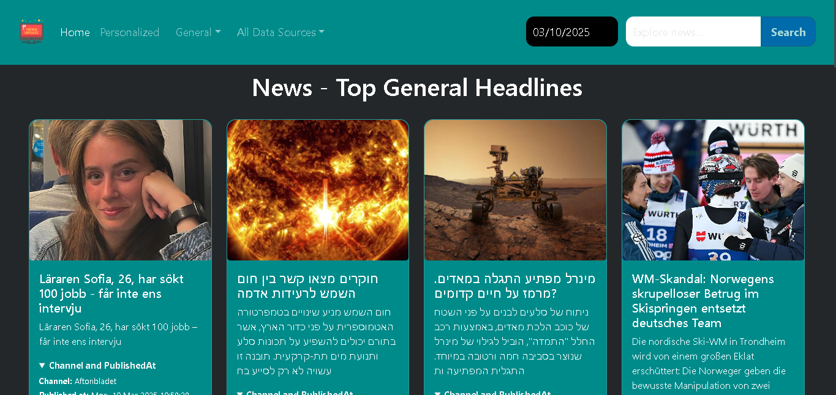

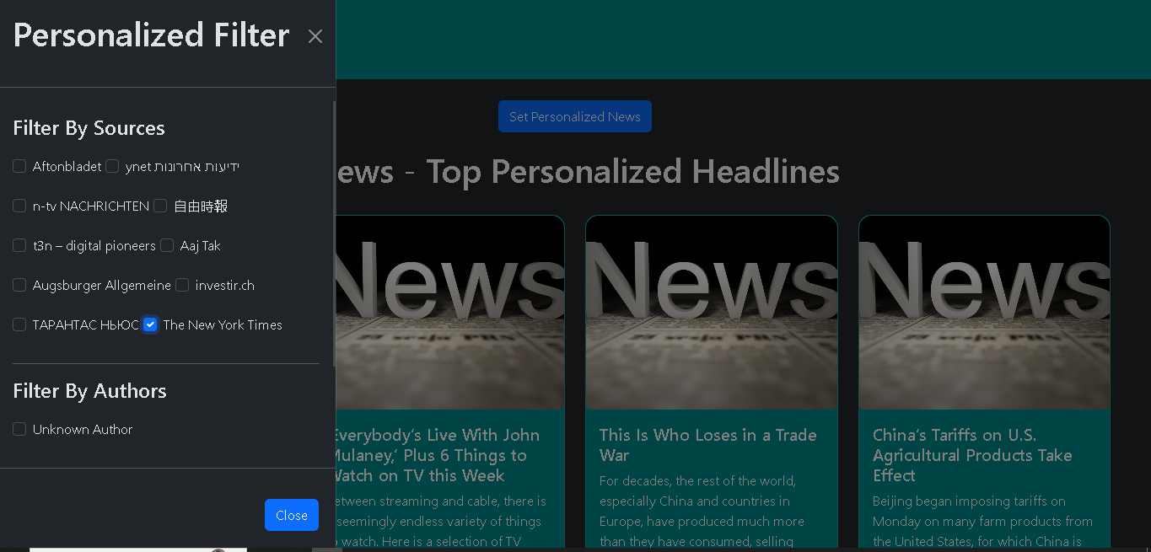

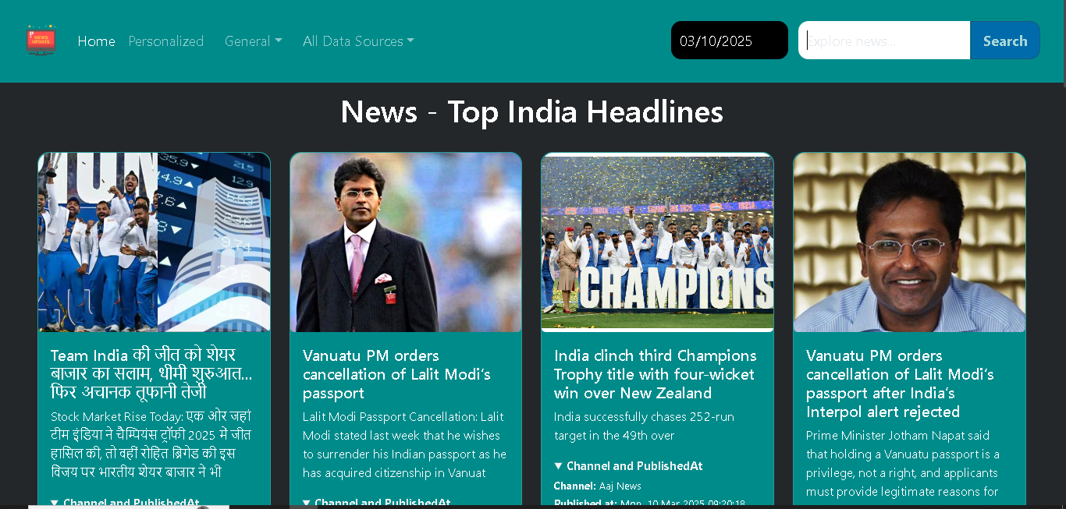

**Project structure:**

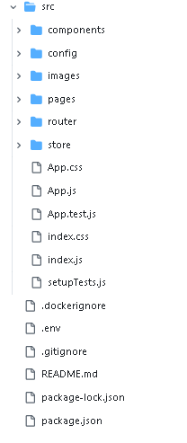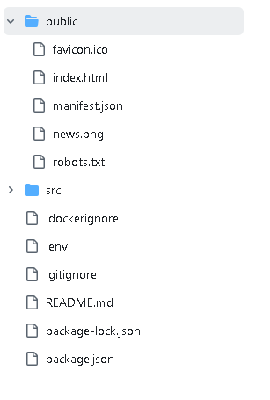

**CONCLUSION:**

In conclusion, the development of the news reading app has provided a comprehensive platform for users to access and engage with news content. The app's features, including personalized news feeds, breaking news alerts, and social sharing capabilities, have enhanced the user experience and facilitated a more informed and connected community.

By following these recommendations and continuing to iterate on the app's design and features, the news reading app can remain a valuable resource for users seeking to stay informed and engaged with current events.